**TEST SUMMARY REPORT**

**CONTENTS:**

1. Purpose
2. Application overview
3. Testing Scope
4. Metrics
5. Types of testing performed
6. Test Environment & Tools
7. Lessons Learnt
8. Best Practices
9. Exit Criteria
10. Conclusion / Sign Off
11. **PURPOSE**

This document explains the various activities performed as part of testing of **“BookMyShow”** application.

1. **APPLICATION OVERVIEW**

“BookMyShow” is a web based ticket servicing application. Tickets for various events, sports, cinemas can be booked using online facilities. The users must sign in with their details, which will be referred before booking is confirmed. There are several options like Registration, Booking and Payment which are integrated to fulfill the purpose.

1. **TESTING SCOPE**
2. **IN SCOPE**

Functional Testing for the following modules are in Scope of Testing

* + - Registration
    - Booking
    - Payment

1. **OUT OF SCOPE**

Performance Testing was not done for this application

1. **METRICS**

|  |  |  |  |
| --- | --- | --- | --- |
| **TEST CASES PLANNED** | **TEST CASES EXECUTED** | **TEST CASES PASSED** | **TEST CASES FAILED** |
| 22 | 22 | 22 | 0 |

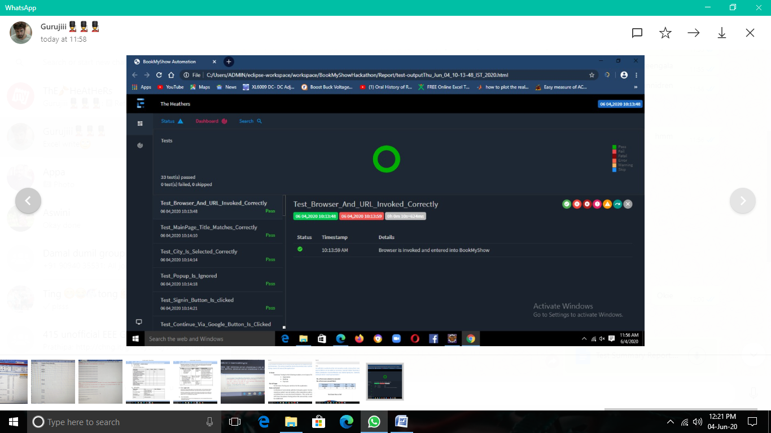

1. **TYPES OF TESTING PERFORMED**
2. **SMOKE TESTING**

This testing was done whenever a Build is received (deployed into test environment) for testing to make sure the major functionalities are working fine, Build can be accepted and testing can start.

1. **REGRESSION TESTING**

* Regression testing was performed each time a new build is deployed for testing which contains the defect fixed and new enhancements, if any.
* Regression Testing is done on the entire application and not just the few functionalities and Defect fixes
* This testing ensures that existing functionalities works fine after defect fix and new enhancement are added to the existing application.

1. **TEST ENVIRONMENT & TOOLS**

|  |  |
| --- | --- |
| **Application URL** | https://bookmyshow.com/ |
| **Tool** | Selenium |

1. **LESSONS LEARNT**

|  |  |  |
| --- | --- | --- |
| **S. NO** | **ISSUES FACED** | **SOLUTIONS** |
| 1 | Smoke testing cases required to be executed manually at each time | Smoke tests were automated and the scripts were run, which ran fast and saved time |

1. **BEST PRACTICES**

A repetitive task done manually every time was time consuming. This task was

automated by creating scripts and run each time, which saved time and resources.

* Smoke test cases were automated and the scripts were run, which ran fast and

saved time.

1. **EXIT CRITERIA**

All test cases should be executed – Yes

1. **CONCLUSION/SIGN OFF**

As the Exit criteria was met and satisfied as mentioned in Section 9, this application is

suggested to ‘Go Live’ by the Testing team.